Activity 3.3: Shopping list
Here is the start of a program that should ask for five items to be added to a shopping list. At the moment it asks for just the first item.
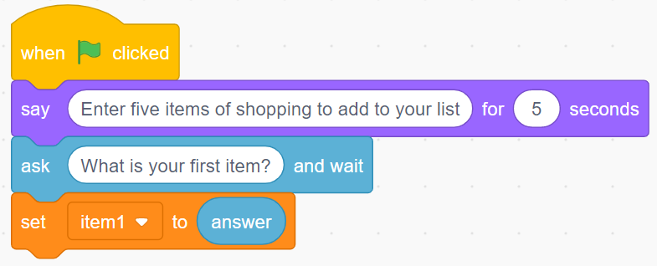
Create these blocks and then add to the program so that it asks for five items and then displays a message that lists all the items entered like this:
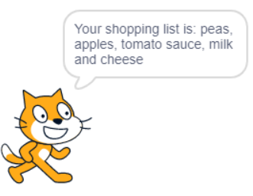

HINT: You will need to create five variables, one to store the answer to each of the five questions.
Don’t forget to screenshot your blocks and paste the screenshot into your evidence document.

